Kelly Wells, Director of Athletics
kellywells@upike.edu

LEADERSHIP
“Leadership is NOT position, rather it is ACTION”

Surround yourself with GREATNESS:

Hire GREAT people, Work with GREAT people, Partner with GREAT people, Hang out with GREAT people, Socialize with GREAT people. Goal-Oriented people.

Michael Jordan didn’t win in the NBA until he began to trust those around him with the Bulls. Phil Jackson and Tex Winter.

Humble:

Nobody in this world is better than you, but you are no better than anyone else.

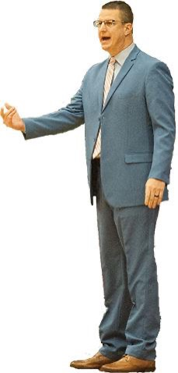
Humility allows you to serve customers more effectively, true leaders understand that all business is personal.

Continually Improve:

Life Long Learners (Podcasts, Zooms, Clinics, Books, Articles, Mentors, Calls, etc.)

Pride. Arrogance & Complacency are enemies of continual improvement

Evolving: Reflect and Reinvent! Don’t let your talent be your nemesis!!!!

Work Hard - Very Hard:

Hard work is something anyone can do, but only a few choose to do.

Required Work vs. Un-Required Work

Hard work will always beat talent and competence when talent and competence don’t work hard.

Do NOT confuse activity with achievement.

Success smells like SWEAT. The man at the top of the mountain didn’t just fall there!

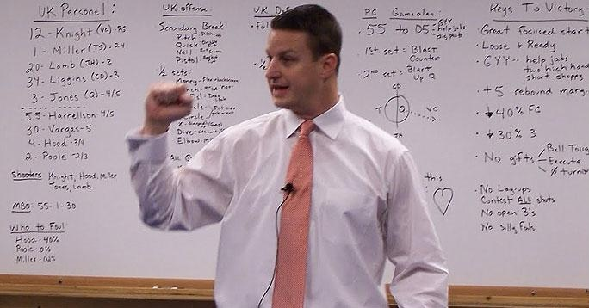
10,000 Hour Rule, “Outliers”: Becoming an Expert in Anything.

Hard Work Eliminates Distractions. Eliminate the Noise.

Nobody motivates the TIGER!

Preparation: The secret of an organization lies in mastering the non-obvious. Everything is important, it all matters.

Form Strong Relationships:

The most important relationships a leader needs to cultivate and protect is the relationship with their family and their maker. Show your commitment!
Work-Life Balance.

Time is a leaders greatest assets because once it is spent, it can never be recovered.

Almost all important decision made about you and your career take place when you are not in the room.

Always leave a trail of kindness and respect behind you. Do not burn bridges.

The oxygen to relationships is TRUST. Deposits made daily.

Shout praise and whisper criticism. Nobody cares how much you know until they know how much you care.

Make Others Better:

Bad company corrupts good character. The power of influence.

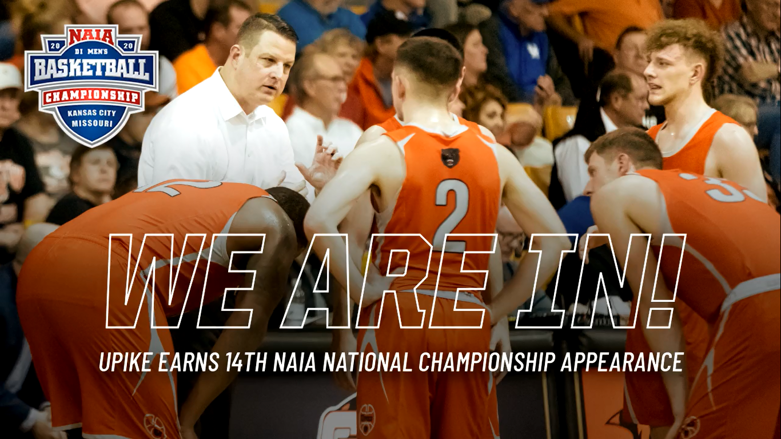
When leaders wait too long to address an issue, it can reach unmanageable proportions. Passivity rarely makes a leader better. It damages credibility.

A man cannot help another without also helping himself.

Take players, coaches, teachers, staff, etc. where they won’t take themselves. Taking someone from where they are to where their best version lies is the mission.

Show Consistency:

A life of integrity without regrets. How well you lead yourself when nobody is watching.

Consistency brings peace, security and reliability to those you lead. Everyone knows what to expect.

Leaders must consistently proclaim the vision over and over and over again. Just when you are getting sick of sharing the vision is when everyone else is starting to get it.

Give Generously:

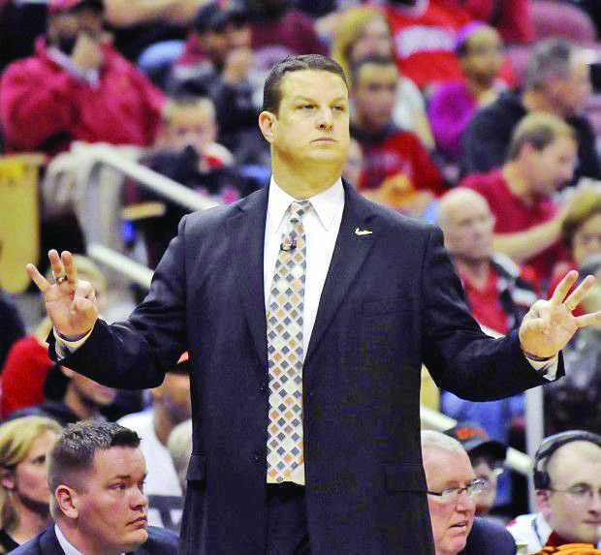
Leaders should always us their influence and platform for shining the spotlight on others and improving the lives of as many people as possible.

I have never missed anything I have given away. Give until it hurts.

Lead by Example:

All of his servants worked right alongside of him. A leader worth following is one who makes great sacrifices for the good of others.

Dream & Believe: Guarantee little, deliver much. Develop the Believe IN!

Deliver Results:

Jesus made every room he entered better.

He that is good for making excuses is seldom good for anything else.

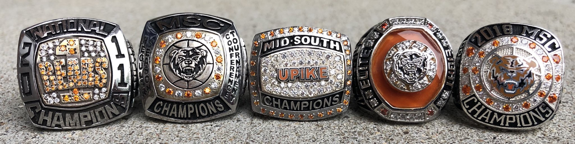
Navy Seals: Failure is not an option. It’s not even an imaginable possibility.

Communication: Truthful, Upfront and Often. Tell the truth, but how you tell them is important.

DO YOUR JOB (Nick Saban - Bill Belichick). *If we all did what we were supposed to do we would always be ok.

High Achievers don’t like mediocre people. Mediocre people don’t like high achievers.

LEAD WITH LOVE
GIVE EXPECTATIONS
HOLD ACCOUNTABLE

